# 23056_Green Warriors_Energy Regeneration System Report

**Author’s Name: Ayush Gupta Co-Author’s Name: Sejal Ahmad**

## INTRODUCTION

We have regenerative braking to implement energy regeneration in the vehicle.

Regenerative braking is an energy recovery mechanism that converts the kinetic energy of vehicle to electrical energy which gets stored in the secondary battery.

This system has two-fold advantages-

* + It converts the kinetic energy that would have been wasted as heat energy on braking to electrical energy which can be reused.
  + It allows the vehicle to stop faster as the added padded wheel provides significant resistance to the motion of wheel.

## CONCEPT AND TECHNICAL FEATURES

The system is implemented using a synchronous motor and a self-designed actuating mechanism that engages the motor when brakes are applied.

Components of the system include:

* 12 V Synchronous Motor
* Yellow Black Tire Wheel
* Self-Designed Actuating Mechanism
* Connecting wires

The synchronous motor, designed for regenerative braking, operates as follows: When brakes are applied, the self-designed actuating mechanism ensures the synchronous motor is engaged, converting the kinetic energy of the vehicle into electrical energy. This electrical energy is then stored in the secondary battery.

The system aims to achieve efficient energy regeneration during braking, providing both environmental and economic benefits. The synchronous motor, with its specific design for this application, enhances the overall performance of the regenerative braking system.

## CALCULATION AND ANALYSIS

Our secondary battery used for powering the electronics of the vehicle is rated 12V and 9Ah.

The synchronous motor used is rated 12V and 6W. Assuming the average energy regeneration and taking into account energy losses the system should produce 4-5 J of energy each second the brakes are applied. To give an idea about this, it would take an application of brakes for a total time of 18 hours to fully charge our battery.

In the case of braking from an initial speed of 25 km/h (6.94 m/s) to a complete stop, to analyze the efficiency of the system we compare the amount of energy regenerated with the amount of energy used in braking.

Now, Braking force on the rear wheel, F = 896.81 N And,

Braking distance, d = 3.6 m Braking time, t = 5 sec

Therefore, total energy used in braking,

E = F*d

= 896.81*5

= 4,484.05J

Thus, energy lost per second,

E/t = 4,484.05/ 5

= 896.81 J/sec

And from our analysis above, energy regenerated=5 J/s

In these calculations the data has been used according to the design specification of the braking system and only the recoverable component of the energy loss has been considered.

### Cost of product

The prices of respective components are:

* 12 V Synchronous Motor – Rs. 599 /-
* Yellow Black Tire Wheel – Rs. 49 /-
* Connecting wires – Rs. 10 / meter x 3 meters = Rs. 30 /-

Therefore, the total implementation cost is Rs. 678 /-.

This cost includes a buffer to cover any other additional anonymous expense for implementation of the proposed system.

### Result & conclusion

Regenerative braking conserve energy lost during conventional braking.

Regenerative braking system has a vast scope for further development and energy savings. The use of more efficient systems could lead to huge savings.

But also like anything else, regenerative braking also has its drawbacks. The most obvious is a decrease in effectiveness at low speeds. In slow-moving stop-and-go traffic, regenerative braking cannot capture much energy and feed it back to the battery, significantly reducing system benefits for many commuters during rush hour.

Regenerative braking system has a wide scope for further development and increasing the energy savings.

### Limitations and future scope

Some limitation includes :

1. MAY BE LESS EFFECTIVE AT LOWER SPEEDS:

The regenerative braking system exhibits limitations at lower speeds. As the fully electric vehicle operates at reduced kinetic energy, the system captures less braking force, resulting in a lower energy feed to the battery pack. Some concerns have been raised by manufacturers that in certain situations, the advantages of regenerative braking might be overshadowed by the benefits of coasting.

1. BRAKE PEDAL MAY FEEL DIFFERENT: The regenerative braking system exhibits limitations at lower speeds. As the fully electric vehicle operates at reduced kinetic energy, the system captures less braking force, resulting in a lower energy feed to the battery pack. Some concerns have been raised by manufacturers that in certain situations, the advantages of regenerative braking might be overshadowed by the benefits of coasting.
2. POTENTIALLY LESS STOPPING POWER: While regenerative braking performs adequately in most gradual braking scenarios, it may not match the stopping force of conventional brakes. Fully electric vehicle drivers might find it necessary to apply increased pressure to achieve the same braking effectiveness.

Scope: Regenerative braking systems play a pivotal role in the optimization of efficiency within fully electric vehicles.

Beyond minimizing energy loss and extending the electric range, these systems contribute to the elongation of brake life due to their low wear and tear characteristics. The evident benefits of this technology enhance the appeal of fully electric vehicles to consumers. Anticipated advancements suggest that regenerative braking systems will become standard features in all electric vehicles in the near future.

### References

1. Kaul, S., Gupta, J., Sharma, S., and Kumar, N., "Scope of Regenerative (Magnetic) Braking in the Production of Electricity in Automobiles," SAE Technical Paper 2013-01-2543, 2013, <https://doi.org/10.4271/2013-01-2543>
2. “Study on Regenerative braking system, considerations of design, safety and associated effects” by Prateek Patel, Harish Chandra, Dr. Tapan Sahoo Maruti Suzuki India Limited
3. Clegg, S.J. (1996) A Review of Regenerative Braking Systems. Working Paper. Institute of Transport Studies, University of Leeds , Leeds, UK.
4. “Regenerative Braking Systems (RBS)” by Pratik Bhandari, Shubham Dubey, Sachin Kandu, Rupesh Deshbhratar
5. Site:[https://www.elprocus.com/what-is-](https://www.elprocus.com/what-is-regenerative-braking-system-working-its-applications/) [regenerative-braking-system-working-its-](https://www.elprocus.com/what-is-regenerative-braking-system-working-its-applications/) [applications/](https://www.elprocus.com/what-is-regenerative-braking-system-working-its-applications/)
6. Studies of Regenerative Braking in Electric Vehicle

M.K Yoong*, Y.H Gan, G.D Gan, C.K Leong, Z.Y Phuan, B.K Cheah. K.W Chew, Member, IEEE

1. Suresh, Sidhu, et al. "Design of Efficycle–Hybrid tricycle with inbuilt KERS.", Proceedings of 8th International

Conference on Engineering and Technology Research

1. Burke, A.F.(2007). Batteries and Ultracapacitors for Electric, Hybrid, and Fuel Cell Vehicles. Proceeding of the IEEE, vol. 95, 4, 806 – 820.

# APPENDIX-1: DESIGN VIEWS AND PHOTOGRAPHS

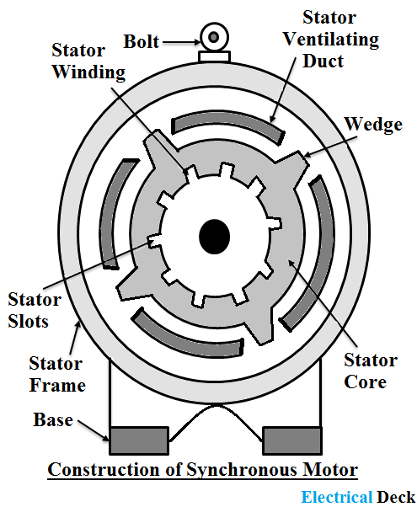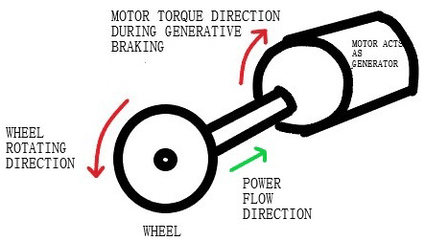

*Figure 1: Components of a Synchronous motor*

*Figure 2: The picture provides a visualization of how the system is implemented*

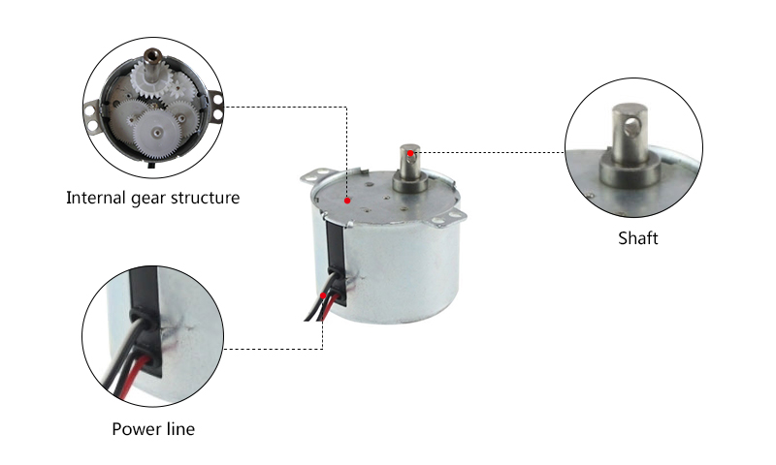

*Figure 2: Different Parts of Synchronous Motor*

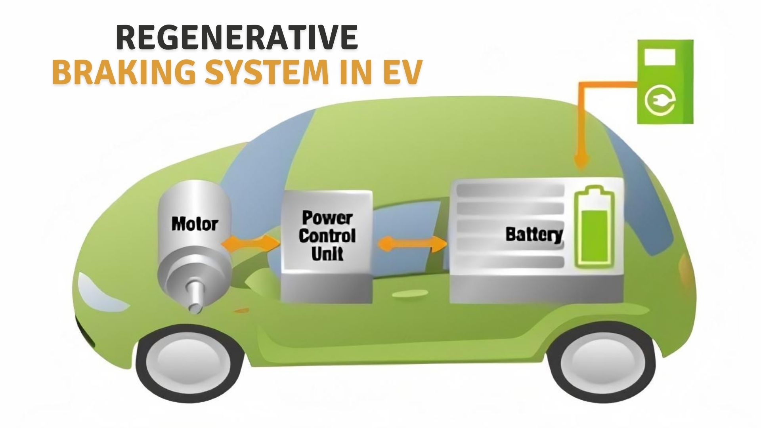

*Figure 3: Regenrative Braking in Electric Vehicl*